TENTATIVE AGENDA
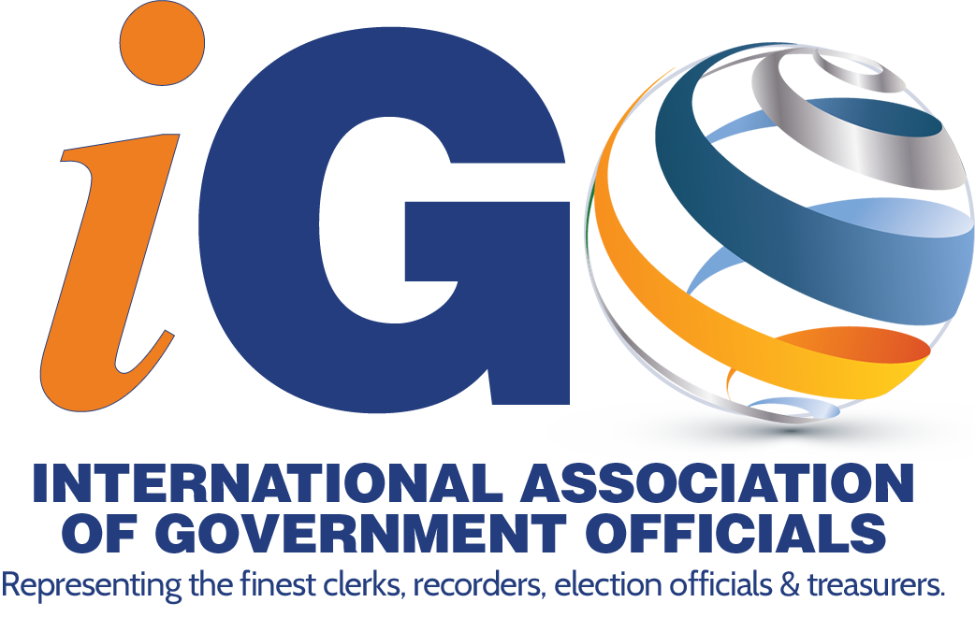
♪ ♬ “Start Spreading The News”♪
iGO’s 4th Annual Conference & Trade Show
JULY 15 – 21, 2021
“Be a Part of It, New York, New York”
Sheraton New York Times Square, New York
Wayne L. Rash, President
DATE | TIME | EVENT
THURSDAY, JULY 15 |  | Early Arrival
FRIDAY, JULY 16 | 9:00 AM | Conference Committee Set Up
SATURDAY, JULY 17 | 8:30 – 5:00 | Registration Opens
 | 9:00 – 12:00 | Committee Roundtables - Open to all attendees
 | 10:00 –11:00 | Delegation Directors Training
 | 11:00 – 12:00 | By-Laws Committee
 | 1:30 - 4:00 | Joint Board Meeting
SUNDAY, JULY 18 | 7:30 – 8:30 | Breakfast
 | 8:00 – 4:00 | Registration
 | 9:00 – 11:15 | Opening General Session-Keynote Speaker, Janine Stange
 | 11:15 – 12:00 | Division Education Sessions
 | 12:00 – 1:30 | Lunch on your own
 | 1:30 – 2:30 | Joint Education Workshop – Janine Stange
 | 2:30 – 4:30 | Division Education Sessions
 | 6:00 – 9:00 | President’s Meet & Greet Dinner
MONDAY, JULY 19 | 7:30 – 8:30 | Breakfast on your own
 | 8:30 – 3:30 | Registration
 | 8:30 – 10:00 | 2nd General Session
 | 10:00 - 12:00 | Division Education Sessions
 | 12:00 – 1:30 | Trade Show Opening Lunch
 | 1:00 – 5:00 | Conference Elections
 | 1:00 - 4:00 | Annual Blood Drive
 | 1:30 – 4:15 | Division Education Sessions
 | 5:00 pm | Trade Show Closes for the Evening
 |  | Evening on your own
TUESDAY JULY 20 | 7:30 – 8:30 | Breakfast in Trade Show
 | 8:30 - 3:30 | Registration
 | 8:30 – 11:00 | Division Education Sessions
 | 11:15 – 12:00 | Trade Show Closing
 | 12:00 – 1:30 | Lunch on your own
 | 1:30 – 3:30 | United Nations Presentation – Virtual Tour/Discussion by UN Rep.
 | 6:00 – 9:00 | Awards Banquet & 2021/2022 Officer Installation
WEDNESDAY, JULY 21 | 9:00 – 12:00 | CPL Course
 | 1:30 – 4:30 | CPL Course
 | 9:00 – 5:00 | 2021/2022 Officer Planning Meeting
THURSDAY, JULY 22 |  | Departure

Registration $565.00 Per Attendee ***SHERATON New York– Room Rate $199.00 +14.75% tax
and $3.50 per night state occupancy tax
Room Reservations online: https://book.passkey.com/go/iGOannualconference2021

