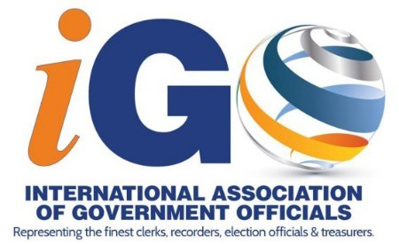
2021 Booth Reservation Form
Sheraton NY Times Square 811 7th Ave, New York, NY 10019 Trade Show: July 19 - 20 2021
$1,250 per 8' x 10' booth

Company Name:

Contact Name:
Company Website URL:

Contact Email:
Contact Phone:

Address:
City: _ State:
Zip: _

Please check boxes that relate to your company/service, ONLY check boxes specific to your target audience:
This information will be used to direct the correct target audience to your booth during the division education sessions.

- An official/officer that is responsible for recording real estate documents, personal records & associated indexes, vital statistics including marriage, birth & death records
- An official/officer whose duties include administration of elections, ballot design, mailing and return of ballots, ballot tabulation, polling places, voter registration, etc.
- An official/officer that manages finances or holds the equivalent of the office of Treasurer
- An official/officer whose responsibility is to file and maintain court documents, acts as Clerk of Court for all types of courts

Booth Selection:
Select your first and second booth selection(s). If you have multiple booths selected include both (or more) booth numbers on the first and on the second booth choices:
1st Choice (booth number/s): _________________________________________ 2nd Choice (booth number/s): ________________________________________
- Each booth reservation includes the opening lunch and a continental breakfast for 2 booth attendees. A booth reservation is not inclusive of conference events such as the President’s Reception, Delegates Lunch, or the Closing Event.
- To attend other meals/networking events individual tickets can be purchased, or to attend the entire conference a full Registration
can be purchased for as low as $545 pp (early registration price) by emailing info@iaogo.org. Conference dates are July 15 - 21, 2021
Booth Payment: $1,250 per 8’ x 10’ booth
  - Credit Card Down payment of 50% of total booth cost is due within 2 weeks of booth selection

Complete the form & pay online
Number of Booths: | Cost per Booth: | Total Cost of Booths:
 | x $1,250.00

  - Check
Mail form and check to iGO at: PO BOX 785
Dunn, NC 28335 USA This form serves as an invoice
Early Registration opens January 2021! Contact igoinfo@iaogo.org to purchase full conference registrations for any of your company’s booth attendants.

for booth payment. Booth Attendant Name: Email:
Cancellation Deadline: Booth Attendant Name: Email:
28 May 2021 Booth Attendant Name: Email:
(no refunds after this date) Booth Attendant Name: Email:

Signature (required):
Date:

Additional company information to be shared on our website and through our Conference App:

Company Email:
Company Phone:

Short Company Description (limit 150 words): ◻ Company Logo Attached (400 x 400 .jpg or .png)

