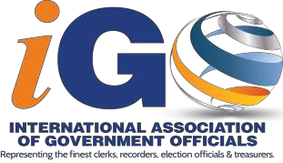
2021 – ^{4th} ANNUAL CONFERENCE
Wayne L. Rash, President

SPONSORSHIP PARTICIPATION LEVELS

PLATINUM LEVEL - $15,000+
- Includes an ad with your company link on our webpage for the year
- Recognition on special sponsor board at registration
- Choose a Premier event to co-sponsor with iGO
- Prime scrolling ad on the iGO conference App
- Two complimentary full conference registrations (includes all events)
- Four additional tickets to your Premier sponsored event
- Remarks & welcome at sponsored event

DIAMOND LEVEL - $10,000+
- Includes an ad with your company link on our webpage for the year
- Recognition on special sponsor board at registration
- An event will be designated to co- sponsor with iGO
- Recognition on Sponsor icon on the conference App
- One complimentary full conference registration (includes all events)
- Two additional tickets to your sponsored event
- Remarks & welcome at sponsored event

GOLD LEVEL - $5,000+
- Recognition on special sponsor board at registration
- An event/item will be designated to co- sponsor with iGO
- Recognition on Sponsor icon on the conference App
- Recognition at sponsored event

SILVER LEVEL - $2,500+
- Recognition on special sponsor board at registration
- An event/item will be designated to co- sponsor with iGO
- Recognition on Sponsor icon on the conference App

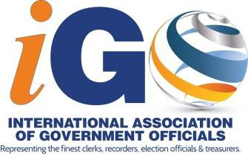
2021 CONFERENCE SPONSORSHIP LEVELS

BENEFIT | PLATINUM | DIAMOND | GOLD | SILVER
 | $15,000 | $10,000 | $5,000 | $2,500
Your ad placed on our website for the year | X | X
Choose a Premier event to co-sponsor with iGO | X
An event/item will designated to co-sponsor with iGO |  | X | X | X
Logo displayed on sponsor banner at registration | X | X | X | X
Scrolling Ad on Conference App | X
Complimentary Full Conference Registrations | 2 | 1
Additional tickets to your sponsored event | 4 | 2
Remarks & Welcome at sponsored event | X | X
Recognition at sponsored event | X | X | X

REVISED: November 21, 2019

